

###### 19/12/2024

###### UNIVERSITY OF RWANDA

###### COLLEGE OF SCIENCE AND TECHNOLOGY SCHOOL OF ICT

###### COMPUTER ENGINEERING

Module Title: INTERACTIVE WEB TECHNOLOGY

NAMES: 1. Eduard GASASIRA 223026683

2.Elyse NIYONZIMA 223027475

3.Kevin NIYONZIMA 223027315

19th December,2024.

PROJECT DETAIL

PROJECT NAME: RWANDA HORIZON TOURS

Contents

Chapter 1. Introduction: 2

1.1 Historical background of the project: 3

1.2 Problem statement: 3

Chapter 2. System Analysis and Design: 4

2.1 System Analysis 4

2.1.1 Functional Requirements of project: 4

2.1.3 Intended System partners 14

2.2 System design: 14

2.2.1 UI Design (sketch of the UI modules) and flow charts: 14

2.2.2 Database design with ERD and relationship: 16

Chapter 3. Implementation: 18

3.1 Introduction of Section: 18

3.1 All screenshots with captions and discuss: 18

Chapter 4. Conclusion 27

Appendix: 28

Figures:

Figure 1: flowchart 15

Figure 2: ERD OF OUR PROJECT 17

Figure 3: HOME PAGE TO MAKE USERS UNDERSTAND OUR WEBSITE 19

Figure 4: MORE PAGE TO EXPLORE OUR PROJECT 20

Figure 5: CONTACT US PAGE TO KEEP INTOUCH WITH OUR WEBSITE 21

Figure 6:BOOKINGS PAGE TO MAKE THE TOURISM BOOK THEIR VISITS 22

Figure 7: LOGIN PAGE TO SECURE OUR PROJECT 22

Figure 8: REGISTER FORM FOR NEW USERS 23

Figure 9: ADMIN DASHBOARD 24

Figure 10 Add admin page (Officer Cadet Management system) 2023-2024 24

Figure 11: DASHBOARD FOR SHOWING BOOKINGS 24

Figure 12: DASHBOARD SHOWING THE LIST OF MANAGERS ADDED TO THE DATABASE 25

Figure 13:PARKS AND OTHER VISIT SITE 26

Figure 14: PAGE SHOWING THE DESCRIPTION OF EACH SITE 26

# Chapter 1. Introduction:

This project deals with the development of a web application to solve some of the problems that face tourism in Rwanda. Tourism is important for Rwanda's economy and culture, but there are challenges that can make it hard for visitors and local businesses.  
  
We would like to create a web application that should ease these issues: making information more accessible to tourists in terms of services, contacts, and connection with guides. In return, our web application also gives space to local businesses to showcase themselves.  
  
In this report, we focus on the problems we identified and how our web application can assist, with steps taken to introduce it. We hope it will help in the improvement of tourism in Rwanda so that both parties will profit from the experience.  
Eventually, it is the aim of the Military Officer Cadet Management System to achieve optimization of all processes of management and decision-making that involve officer cadets. The system allows for smooth workflow, transparency, and real-time access to information necessary for instructors, platoon commanders, and company commanders in making well-informed, timely decisions regarding the disciplining and performance of cadets and their possible dismissal.  
  
  
The goal of our web application is to solve some very important problems in the tourism sector of Rwanda. Some of the challenges identified include how tourists find information and book services, and how local businesses connect with visitors. Our application makes it easy for tourists to access what they need and helps local businesses connect with visitors.  
  
We strongly believe that with the use of this web application, tourism can increase and improve in Rwanda. It will offer better experiences for tourists and thus benefit the local communities as well. Our project highlights how technology can make a difference in the tourism sector. We hope this is just the beginning of new opportunities for Rwanda's tourism.

## Historical background of the project:

Rwanda has an interesting history to tell, which has actually influenced its tourism today. In the past, it was famous for its beauty in landscapes, animals, and rich culture. Many tourists came to see the mountain gorillas in Volcanoes National Park and learn about local traditions.  
  
But unfortunately, the 1990s were the darkest moment in Rwanda's calendar as it faced a sad and painful event called the genocide. The country worked tooth and nail to rebuild itself after the tough period, also promoting peace afterward. Tourism was one of the important sectors that the government thought would help the people of Rwanda improve their economy and lives.  
  
Tourism has changed a lot over the years in Rwanda; some changes were positive, especially on the development of attractions and improvements in roads. Still, there are various obstacles, such as issues regarding finding information and being in contact with local services.  
  
This project builds upon the tourism story of Rwanda. After finding tourism as one of the most important sources of income for our country, we are aiming at solving some of these ongoing problems and helping the tourism industry grow even more, hence benefiting both visitors and locals.

### 1.2 Problem statement:

Despite the expansion of tourism in Rwanda, there is still a number of problems for tourists and the local private sector: Information on attractions, activities, and accommodations is often lacking, insufficient, or non-existent. This may affect tourists who cannot get full information or useful advice on their trips to Rwanda.  
  
Then, local businesses such as hotels, restaurants, and guides often are unable to attract tourists because they lack many different tools through which they would be able to promote or manage bookings for their businesses. It also means tourists and locals miss out on great experiences and opportunities for business.  
  
Finally, the inability to communicate between tourists and native service providers can lead to misunderstandings and dissatisfaction. This might not only affect the travelers but also the country at large in terms of further travel to Rwanda.  
  
Rwanda Horizon Tours is therefore developed to solve these problems, and it is intended to have a user-friendly web application for tourists in order for them to search for any information and contact the available local services. This should enhance the visitors' stay and benefit the local providers in Rwanda.

#### Objectives of your Project:

The main objectives of our project are to:

1. Provide Easy Access to Information: We want to create a web application that gives tourists clear and helpful information about places to visit, things to do, and where to stay in Rwanda.

2. Connect Tourists with Local Businesses: The project shall help local hotels, restaurants, and tour guides reach tourists with ease; this will assist visitors in finding and booking their services quickly.

3. Improve Communication: We want to make it easier for tourists and local service providers to communicate, thus reducing misunderstandings and helping all to have a better experience.

4. Supporting Local Communities: In supporting local businesses through our web application, we also want to help in growing the economy of Rwanda and opening more employment opportunities for the people.

5. Improve Overall Tourism Experience: The overall experience for tourists while traveling in Rwanda will be developed. We want them to have enjoyable and memorable trips as they discover the beauty and culture of the country.

These objectives will guide us as we develop the web application, ensuring it meets the needs of both tourists and local businesses in Rwanda.

# Chapter 2. System Analysis and Design:

## 2.1 System Analysis

### 2.1.1 Functional Requirements of project:

Our website will have user registration and login, searching for attractions and services, and detailed listings that include descriptions, photos, and prices. Tourists can directly book their accommodation and tours and review with ratings. It will also include an integrated map to help in navigation and profile pages where local businesses can advertise their services. Customer support will be available through a chat feature section. The app will be multilingual and responsive, thus providing an easy experience for both tourists and local businesses in Rwanda.

Here are some key functionalities the system will contain:

Landing Page Description

1. Home  
The "Home" section will introduce a short description of the app, highlight the main features, and show some nice pictures of Rwanda's attractions to invite users for more information.  
  
2. More  
In the "More" section, users can get additional information about the app. This will describe what the app does and how to use it, including stories or reviews from other users and local businesses to build trust.  
  
3. Book Yours  
We proposed to include the section "BookYours," by means of which tourists can get connected with hotel, tour, and activity booking with ease. This section should include an easy form and filter choices based on user requirements.  
  
4. Contact Us  
In this regard, the section "Contact Us" will explain the means users will find helpful to contact in getting help or information. There will be contact forms, email addresses, telephone contact, and a link connecting to social networks for effortless communication.  
  
5. Menu  
“Menu" will facilitate navigation in the app and provide links with important sections, such as attractions, services, and user accounts, so it will be easy for any user to find what he is looking for.  
  
On the whole, the landing page should be clear and attractive; it should introduce users to everything that Rwanda can offer.

Authentication and Authorization in Rwanda Horizon Tourism Project

In regard to the Rwanda Horizon tourism project, authentication and authorization would, therefore, be employed as key factors that show concern for security and preference for personalization, while on the platform, in particular, for tourists or local businesses.  
  
Authentication

In relation to this system, authentication for tourists and business owners will start when both groups create an account on this system. They will provide a username and password as credentials to register. With this information, they will log in when they come back to the site. This process will ensure that only authorized users can access their personal information, bookings, and business profiles. If a user forgets their password, a secure password reset option will be available, enabling them to regain access safely.  
  
Authorization

After the authentication of users, authorization will define what they can do within the application. For example, it will include attraction browsing for tourists, booking accommodations and tours, and ability to leave reviews, while for locals it provides profiles of their business where they can update information, manage bookings, and respond to reviews. In this way, different features will be provided based on user roles, so no one can access others’ parts except their own, which adds in security and usability.  
  
The Rwanda tourism venture will ensure the security of users’ information and a personalized experience that will have been met by both tourists and local businesses through stringent authentication and authorization processes.

Login Section Description

The login section in the Rwanda tourism project will be designed to be user-friendly and secure, allowing users to access their accounts without any hustle.  
  
Layout  
Input Fields: The login section will contain two major input fields:  
Username/Email: A field where a user can input their registered username or email address.  
Password: A field where a user will input their password. This field will mask the characters for security.  
Password Recovery Link: Besides the password field, there should be provided a

"Forgot Password?" link. It will redirect them to a secure password resetting procedure.

Login Button: There must be a very evident "Login" button users would click to submit their information and log in.

REGISTER FORM DESCRIPTION

The Rwanda tourism project's registration form will be in a user-friendly and secure manner, which will enable new users to create an account with ease. Here is how it will be structured:  
  
  
Input Fields: The registration form will include the following fields:  
Full Name: A field for users to enter their full name.  
Username: A unique username field that will be used for login.  
Email Address: A field for entering a valid email address.  
Password: A password input field where users will create a secure password.  
Confirm Password: A field to re-enter the password for verification.  
User Type Selection: A drop-down list or radio buttons to choose from the following:  
Tourist: The user is a tourist looking to see the various attractions and book services.  
Local Business Owner: If he or she wants to register a business on this website.  
Terms and Conditions: A checkbox to let users agree with the terms and conditions of the service. A link to the terms will be provided for users to read before agreeing.  
Register Button: A clear and prominent "Register" button that submits the form.  
Design Features  
Clean and Simple Design: The layout will be straightforward, ensuring users can easily read and fill out the form.  
Responsive Design: The form will be responsive to work well on desktop and mobile devices.  
Validation and Security  
Input Validation: It will check in real time that all the fields are correctly filled in, such as valid email format, password strength.  
Secure Password Storage: Passwords will first be hashed before storage in the database.  
Email Verification: Users will receive an email after registration to verify their email address before logging in.  
User Experience  
Success Message: Upon successful registration, the user will receive a confirmation message with an invitation to verify their email address.  
Redirect Option: After verification, the user can be automatically taken to the login page or account dashboard.  
In this way, the register form will ensure ease in onboarding for users, hence guaranteeing easy and secure addition of both tourists and local business owners to the Rwanda tourism project.

ADMIN DASHBOARD

The Rwanda tourism project dashboard provides an overview of the local business owners' activities and interactions. Below is an explanation of each feature on the displayed dashboard:  
  
1. Welcome Message  
Description: The welcome message that pops up shows a personalized message that greets the user of the application, making the experience more interactive.  
Purpose: It creates a friendly atmosphere and confirms that the user is in the right place, enhancing user satisfaction.  
2. Visitor Statistics  
Total Visitors   
Description: This is the number of visitors who have viewed the user's profile or business page. The purpose is to help the business owner gauge interest in their offerings and their visibility. Pending Visitors (0): Description: This is the number of visitors who have shown interest but have not further engaged, for example, inquiries or bookings. Purpose: It alerts the owner to potential customers that they may want to follow up with. Approved Visitors (1):  
Description: This is the number of visitors who have taken a further step in confirming a booking or inquiry, for instance. Purpose: It helps the owner understand how effectively they are converting interest into actual engagements. 3. Total Hotels (5) Description: This is the number of hotels or accommodations that the user has listed on the platform. Purpose: It gives the business owner a quick view of their inventory and helps them manage their offerings effectively.  
4. Total Managers   
Description: This feature indicates how many managers or staff members are associated with the user's business account.  
Purpose: It helps the owner understand the size of their management team and can facilitate collaboration within the platform.  
5. Quick Access Links  
Categories Menu:  
Description: A sidebar menu provides quick links to different sections like "Message," "Parks," "Transport," "Team," and "Analytics."  
Purpose: It allows for easy navigation of the dashboard and allows users to access quickly and without clutter the information needed.  
6. Download as PDF Button  
Description: This is a button that a user can click to download their information that they have on their dashboard into a PDF.  
Purpose: Give the user the ability to print out their statistics and activity, which might be handy in reports or meetings.  
Overall User Experience  
It's designed to be intuitive and informative-to make sure that, at a glance, a local business owner is getting the most critical metrics. The design of this layout is very user-friendly, allowing users to find and then use what they want. Equipped with visitor statistics, hotel management, and team oversight, it's going to offer the full scale of visibility a business will get online, enabling proper decision-making and engagement.

HOTEL DASHBOARD

The Rwanda tourism hotel dashboard will be customized for use by managers and owners in managing the properties. Given below is a detailed overview of all the features which may appear in the Hotel Dashboard:  
  
1. Overview Section  
Description: A briefing of major metrics that should give the snapshot of hotel performance.  
Features:  
Total Bookings: It provides the total number of bookings made to the hotel.  
Occupancy Rate: It shows the total available rooms that are currently occupied.  
Revenue Generated: Conveys the total revenue earned over a certain period of time.  
Purpose: Here, managers can view a summary for immediate assessment of hotel performance.

2. Manage Bookings  
Description: This is a section from where one can manage all bookings.  
Features:  
Upcoming Reservations: All the upcoming bookings are listed along with the guest information, check-in, and check-out dates.  
Manage Reservations: Provide options to confirm, modify, or cancel bookings.  
Purpose: This feature streamlines the booking process, helping managers stay organized and responsive to guest needs.

3. Guest Management  
Description: Tools for managing guest information and interactions.  
Features:  
Guest Profiles: Access to detailed profiles including contact information, booking history, and preferences.  
Feedback and Reviews: A section to view and respond to guest reviews and ratings.  
Purpose: Enhancing guest relations and improving service based on feedback.

4. Room Management  
Description: A section for overseeing room availability and status.  
Features:  
Room Inventory: The amount of rooms available, occupied, and out of order/maintenance.  
Room Rates: To set and alter the rates of different types of rooms.  
Purpose: To ensure that room availability is monitored and price mechanisms are correctly applied.

5. Analytics and Reports  
Description: Performance analysis tools that measure key indicators over time.  
Features:  
Performance Reports: Provide detailed reports on bookings, revenues, and occupancy rates.  
Market Trends: An insight into local tourism trends, showing competitor performances.  
Purpose: Assists managers in making informed decisions based on data analysis.

6. Marketing Tools  
Description: Features to promote the hotel and attract guests.  
Features:  
Special Offers: Creation and management of promotional deals and packages.  
Social Media Integration: Tools to share updates and promotions on social media platforms.  
Purpose: More visibility and attraction of guests through effective marketing strategies.  
7. Support and Resources  
Description: Access to help and support resources.  
Features:  
Help Center: FAQs and guides for using the dashboard.  
Contact Support: Options to reach customer support for assistance.  
Purpose: Ensures users have the help they need to effectively manage their hotel

TRANSPORT DASHBOARD

The transport dashboard in the Rwanda tourism project is designed for transport service providers, offering tools to manage bookings, vehicles, and customer interactions effectively. Here's an analysis of the key features that might be included in the transport dashboard:  
  
1. Overview Section  
Description: A summary providing a snapshot of transport operations.

Features:

Total Bookings: Displays the number of transport bookings made.  
Active Rides: Shows the number of ongoing rides in real-time.  
Revenue Generated: Highlights the total revenue earned from transport services over a specified period.  
Purpose: This section allows transport providers to quickly assess their operational status and financial performance.

2. Booking Management  
Description: A dedicated area for managing transport bookings.  
Features:  
Upcoming Bookings: Lists all scheduled rides with customer details, pickup, and drop-off locations.  
Manage Bookings: Options to confirm, modify, or cancel bookings as needed.  
Purpose: Simplifies the booking process by allowing providers to organize and be responsive.

3. Vehicle Management  
Description: Tools for managing fleets of vehicles.  
Features:  
Vehicle Inventory: Number of available, in-use, and in-maintenance.  
Vehicle Details: Capacity, registration, and maintenance records of each vehicle.  
Purpose: Enables the easy handling of fleet management, bringing optimum output and safety.

4. Driver Management  
This section is used to manage the drivers associated with the transport service. Features: Driver Profiles: Detailed profiles of each driver, including contact information, availability, and performance metrics. Driver Assignments: Driver assignment to bookings and performance tracking tools. Purpose: It enhances operational efficiency through effective driver resource management.

USERS OF OUR PROJECT

1. TouristsDescription: People or groups visiting Rwanda for leisure, adventure, or cultural experiences.  
Needs:  
Access to information related to attractions, accommodations, and transport options.  
Features for booking hotels, tours, and transport services.  
Review and sharing tools.

2. Local Business Owners  
Description: Owners or managers of hotels, restaurants, tour companies, and other tourism-related businesses.  
Needs:  
A dashboard to manage bookings, customer interactions, and business performance.  
Marketing tools to promote their services.  
Analytics for business performance tracking and customer feedback.

3. Transport Service Providers  
Description: Companies or individuals offering transport services like taxis, shuttle services, or rental cars.  
Needs:  
A platform for managing bookings, vehicle inventory, and driver assignments.  
Tools for performance tracking and revenue tracking.  
Customer management for improving service provision.

4. Tour Guides  
Description: Individuals offering guided tours and local experiences to tourists.  
Needs:  
Tools for booking management and customer interaction management.  
Features for service showcasing and feedback provision.  
Access to training and resources for the enhancement of their skills.

5. Tourism Authorities  
Government or non-governmental organizations focused on the promotion and regulation of tourism in Rwanda.  
Needs:  
Analytics and reporting tools to study the trends in tourism and the impact it has on society.  
Features to showcase and promote tourism initiatives and events.  
Collaboration features for communicating with local businesses and stakeholders.

6. Event Organizers  
Description: Individuals or organizations who organize events, conferences, or festivals in Rwanda.  
Needs:  
Tools for coordination: logistics, venue, services.  
Access to a network for finding out about local vendors and services.  
Event posting feature for tourists and locals.

7. Travel Agencies  
Description: Plan and organize trips including travel arrangements for clients.  
Needs:  
Access to a full database of local amenities and service providers.  
Tool for reservation management and communicating with clients.  
Means to create custom package

ROLES MANAGEMENT

This is the section of the dashboard for the Rwanda tourism project, dedicated to the "Managers List." Herein is a detailed analysis and description of its components.  
  
1. Title and Context  
Title: "Managers List"  
Context: The section falls under the administrative interface, where staff associated with the different services in the tourism project can be managed.

2. Table Structure  
The actual content is presented in a tabular format for clarity of multiple entries.

Columns:  
Name: The names of the managers are listed here.  
Email: Email addresses through which they can be reached.  
Telephone: Contact numbers for each manager.  
Post: The role or position of each manager within the organization.

3. Data Entries  
There are a number of rows in the table, each for a different manager:  
Names: A combination of first and last names, indicating a variety of individuals involved at different levels of the project. Email Addresses: Professional emails are included, showing a well-organized communication system. Telephone Numbers: Contact numbers are provided for direct contact. Post Roles: Some roles are marked as "Unassigned," while others mention the service involved, such as Transport, Hotel, and Park.

4. User Interface Elements  
Scroll Bar: The presence of the scroll bar means there may be more entries not currently viewed, suggesting the list can grow and accommodate many managers.  
Button for Downloading PDF: A "Download PDF" button is visible allowing the user to export the list for offline access or reporting purposes.

5. Design and Usability  
Clean layout: It is organized well in a table, improving readability and thus the potential of the user finding any given information from it.  
Interactivity: The interface appears to be very friendly; interactions such as sorting or filtering this list can be performed.

6. Purpose and Implications  
Management Tool: This part will provide a very useful management tool in terms of managing staff involved in the tourism venture.  
Communication: Providing the contact information, the dashboard will be able to further assist the manager in communicating with their team.  
Role Assignment: The ability to see which roles are unassigned helps in identifying staffing needs,

### 2.1.3 Intended System partners

The Rwanda tourism project can benefit from a variety of partners across different sectors. Here's a breakdown of potential partners:  
  
1. Government Agencies  
Ministry of Tourism and Wildlife: To promote tourism policies and initiatives.  
Rwanda Development Board-RDB: For investment promotion and tourism development.  
Local Government Authorities: To support local tourism initiatives and infrastructure development.

2. Local Businesses  
Hotels and Lodges: Partnerships with accommodation providers to offer packages and promote stays.  
Restaurants and Cafes: Partnerships to develop food experiences for tourists.  
Transport Services: Taxis, shuttles, and car rentals will be available for easy transportation.

3. Tour Operators and Travel Agencies  
Local Tour Companies: In order to develop guided tours and packages.  
Travel Agencies: To promote travel packages to include a variety of attractions and places of accommodation locally.

4. Cultural and Community Organizations  
Cultural Heritage Organizations: For promoting cultural tourism and heritage sites.  
Local Communities: Engaging local communities for authentic experiences and sustainable tourism.

5. Technology Partners  
Software Development Companies: Partnerships in developing and maintaining the digital platform.  
Payment Gateway Providers: For secure online transactions and bookings.

6. Marketing and Advertising Agencies  
Digital Marketing Firms: To promote the project using online channels and social media.  
Tourism Marketing Organizations: For wider promotional campaigns among international tourists.

7. Non-Governmental Organizations (NGOs)  
Environmental NGOs: To ensure that tourism practices are sustainable and conservation is in place.  
Social Enterprises: To address community development and responsible tourism initiatives.  
8. Educational Institutions  
Universities and Colleges: For research collaborations, training programs, and internships in tourism and hospitality management.

### System design:

### 2.2.1 UI Design (sketch of the UI modules) and flow charts:

In Generally this this logic behind this website.

. Flowchart

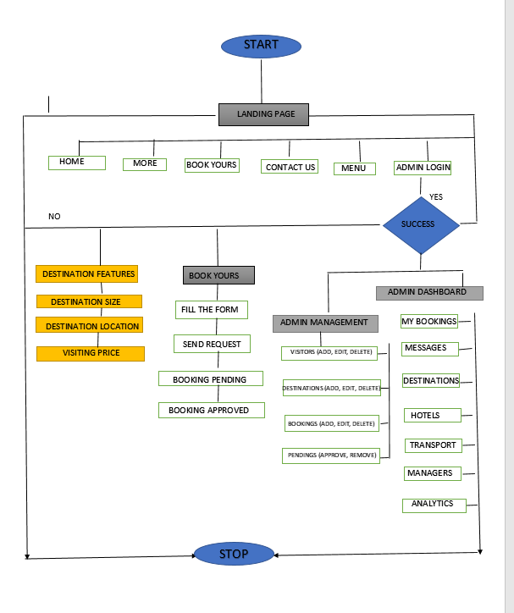

Figure 1: flowchart

### Database design with ERD and relationship:

ERD (Entity Relational Diagram)

Below are my Entity Relational Diagram for my Database with their Relationship:

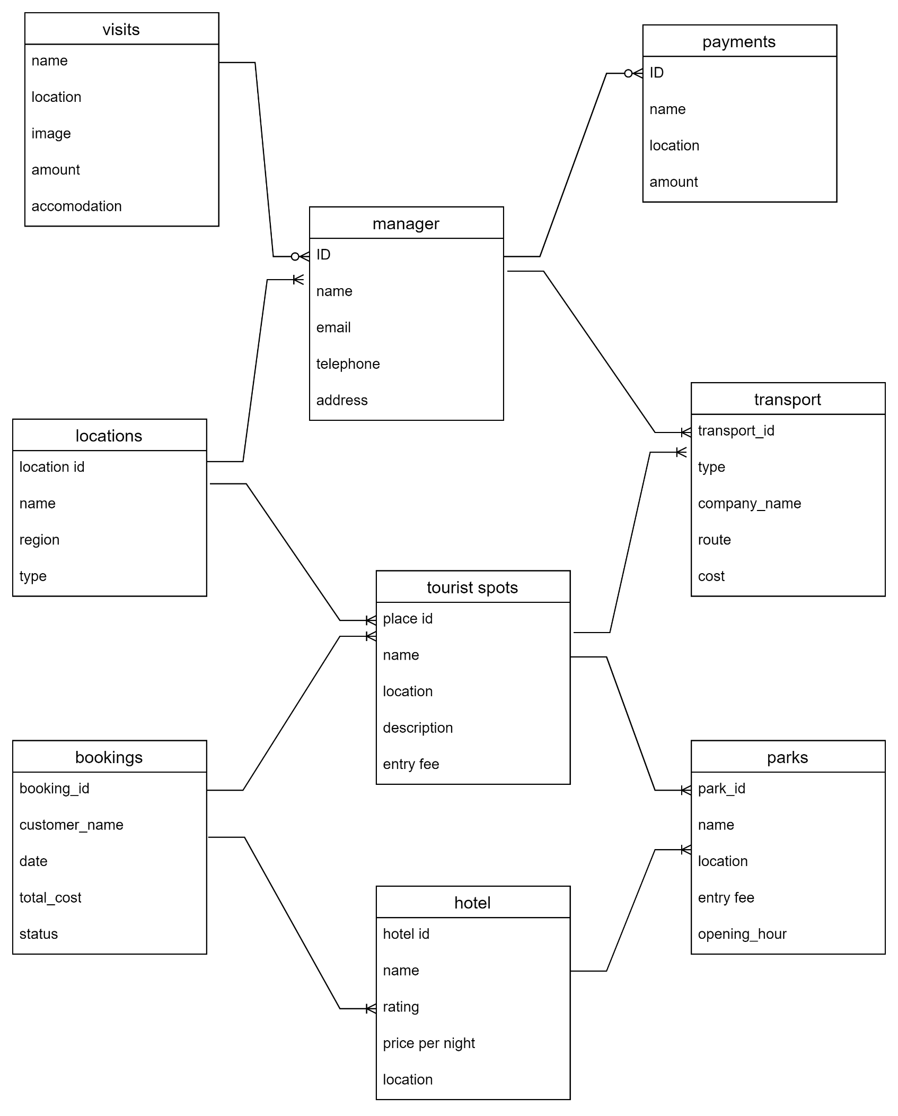

Figure 2: ERD OF OUR PROJECT

# Chapter 3. Implementation:

# 3.1 Introduction of Section:

IMPLEMENTATION

Our system will be implemented with a focus on user satisfaction, ensuring that users can seamlessly perform all activities through their personalized portal. The user portal will include all the essential options required for the basic functionality of the system, as well as user self-management tools tailored to individual needs.

Users will also have the flexibility to update their personal information whenever necessary and customize the system's functionality based on their preferences and access privileges. The following system functionalities, along with detailed visuals, illustrate how the *Tour Horizon Rwanda* system operates to enhance the user experience.

# 3.1 All screenshots with captions and discuss:

* Landing Page:

The landing page of the web application serves as the initial point of interaction for users and provides an overview of the tour horizon Rwanda System.

The landing page of the web application welcomes users by display all natural beautiful of our country and they will display them selves as we have them in database and us you can see there are some descriptions for them such as: size, location and the price to visit the place.

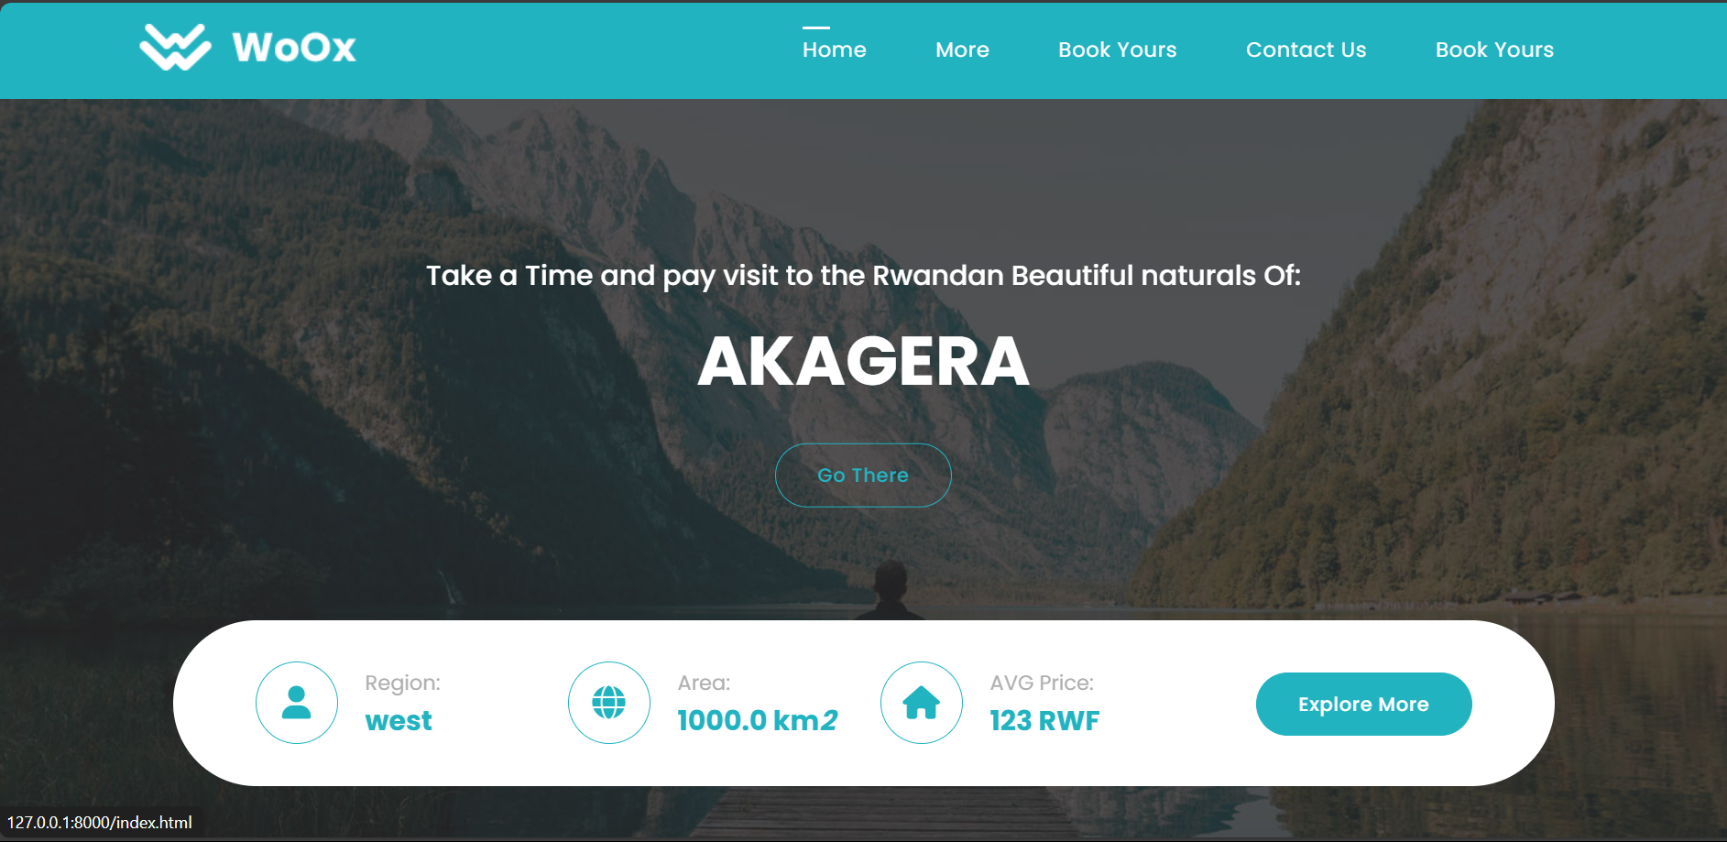

Figure 3: HOME PAGE TO MAKE USERS UNDERSTAND OUR WEBSITE

More page:

The more page is a page that we designed to display more information for the place that user desired to visit and this page contains all underground information for the place.

And as you can this here the user desired to visit Nyungwe national park and the page is welcoming and informing him about Nyungwe national park.

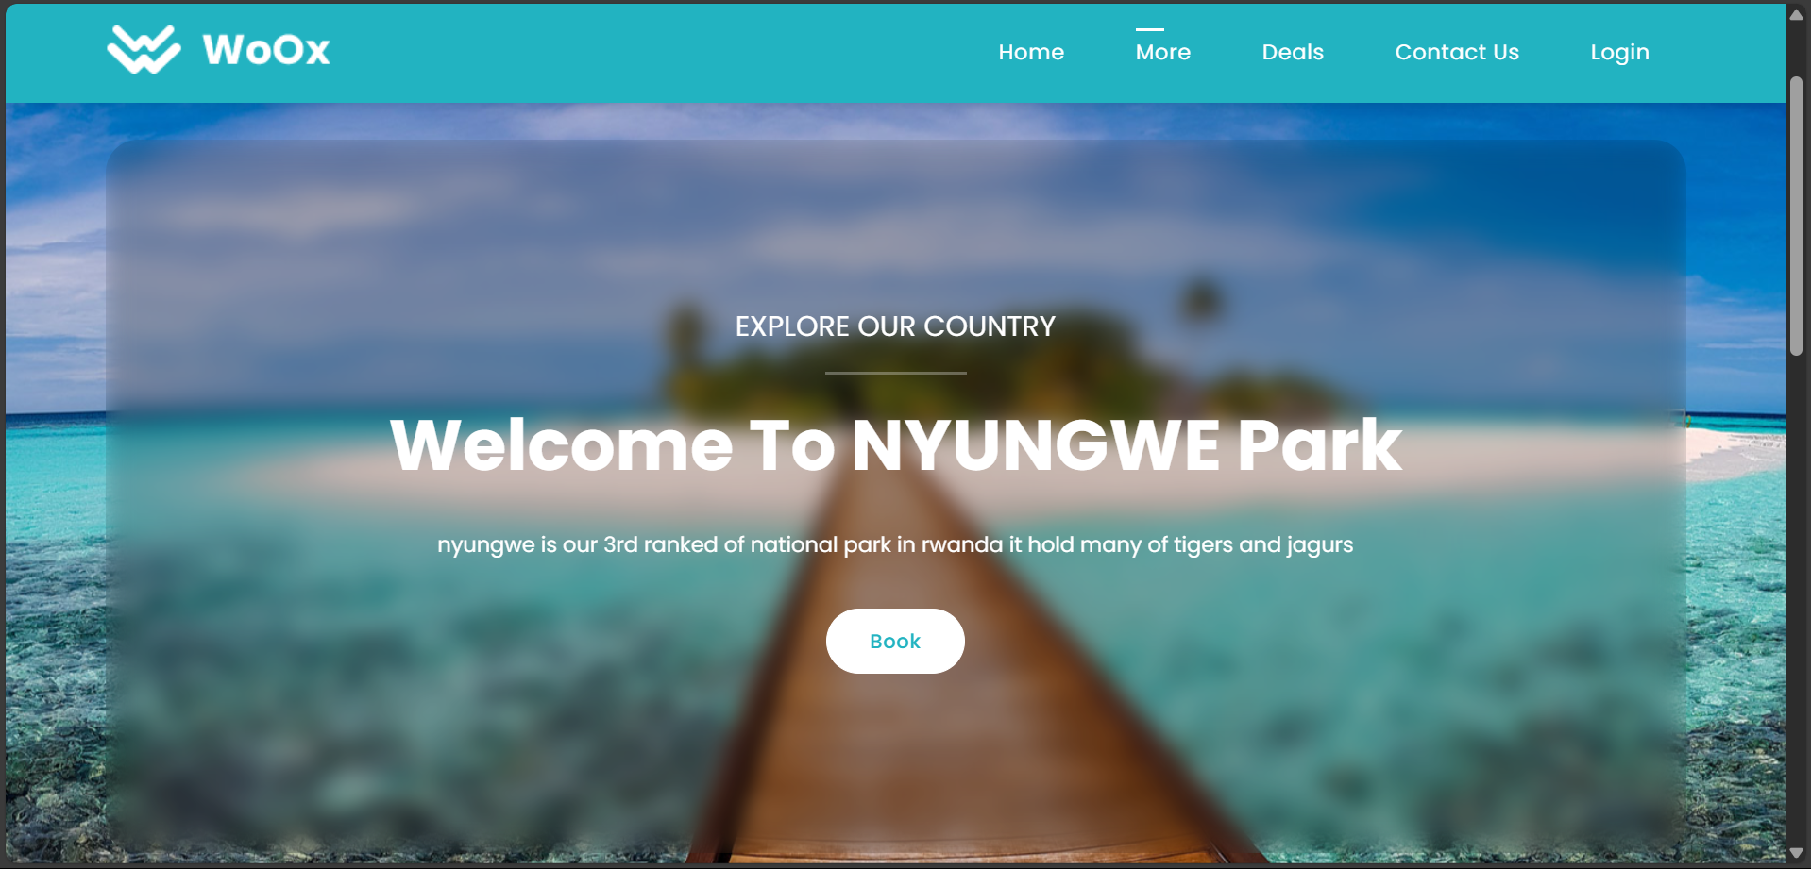

Figure 4: MORE PAGE TO EXPLORE OUR PROJECT

**Contact page:**

The Contact page on your website serves as a direct point of communication between administration and visitors who are interested in your services or have inquiries. This page allows visitors to easily reach out to you, fostering engagement and providing a means for further interaction.

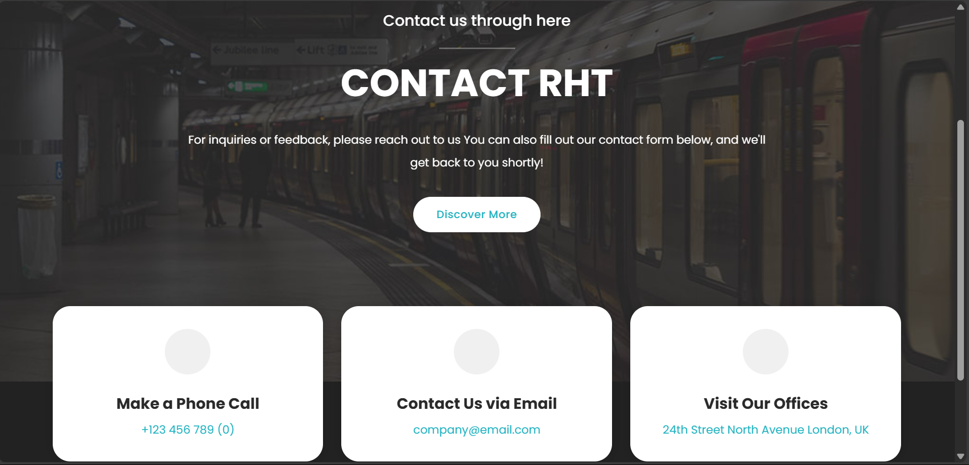

Figure 5: CONTACT US PAGE TO KEEP INTOUCH WITH OUR WEBSITE

**BOOK YOURS PAGE:**

This page provides a clean and interactive booking form for users to plan their visits efficiently. It allows users to select a **location**, specify a **place to visit**, choose a **hotel**, and select their preferred **transportation means**. The form also includes fields for entering the **start and end dates** of the visit, as well as the user's **name**. There’s an option to **upload an image**, likely for personal identification or customization purposes. At the bottom, a clear **"Book Yours"** button enables users to submit their bookings seamlessly. The page design is simple, with a bright color scheme that emphasizes usability and modern aesthetics.

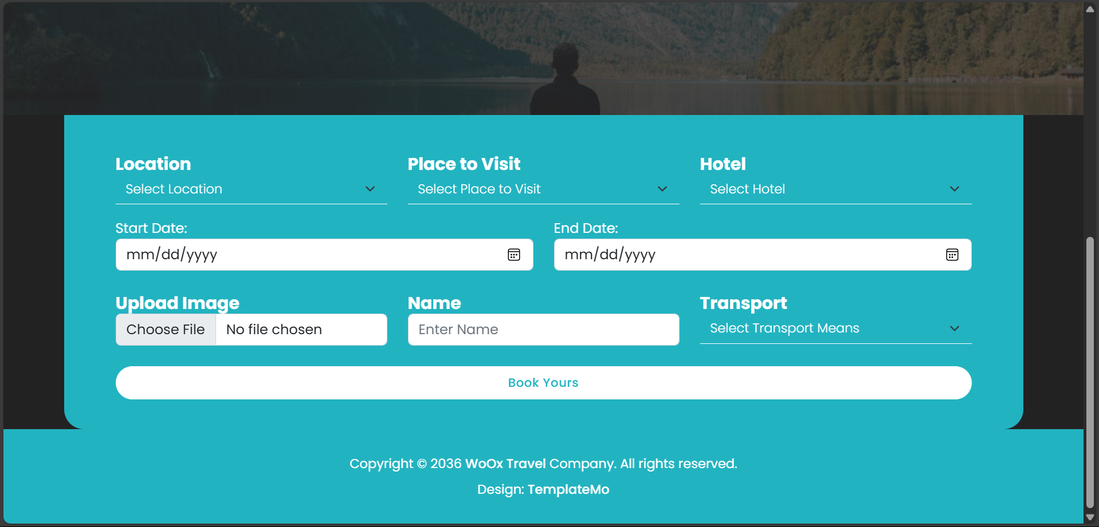

Figure 6:BOOKINGS PAGE TO MAKE THE TOURISM BOOK THEIR VISITS

**MANAGER LOGIN PAGE:**

This is the login page for manager, where the manager has to login before have an access to dashboard and if the manager don’t have an account that means he/she is not known as you see below in picture there is link that will direct him/her to registration form to create an account.

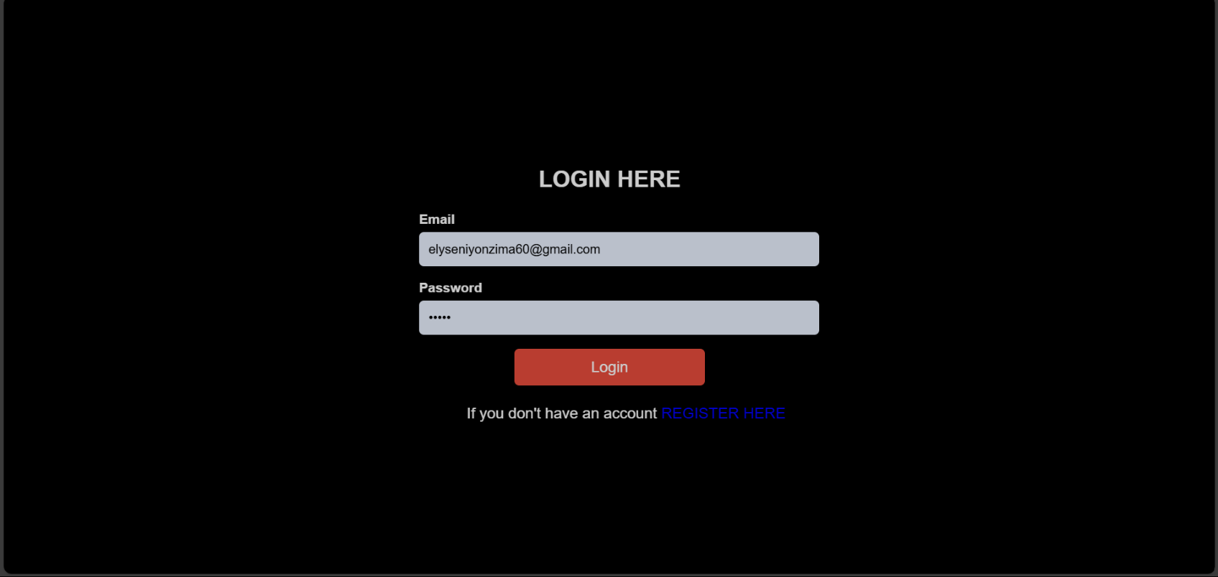

Figure 7: LOGIN PAGE TO SECURE OUR PROJECT

**MANAGER REGISTRATION PAGE:**

.

The registration page in this website is more important because it will help manager to create his/her own account and that essential thing for them after fill the form below the account will be declared automatically in database and then the manager will have an access to dashboard.

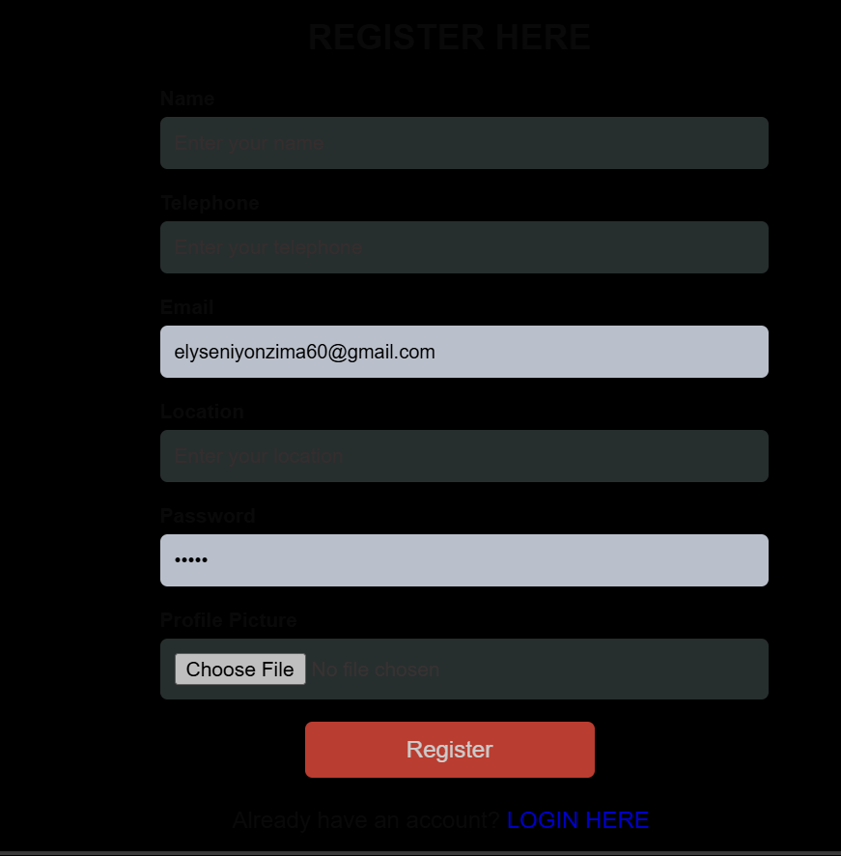

Figure 8: REGISTER FORM FOR NEW USERS

**DASHBOARD PAGE:**

As we all know dashboard is the skeleton of website so, our dashboard page as you can see can only accessed by registered managers, below the manager that logged in was teta hope and for more info its will show the manager total visitors, pending visitors, approved visitors, total hotels available and then total manager and further more give the manager access to make modifications.

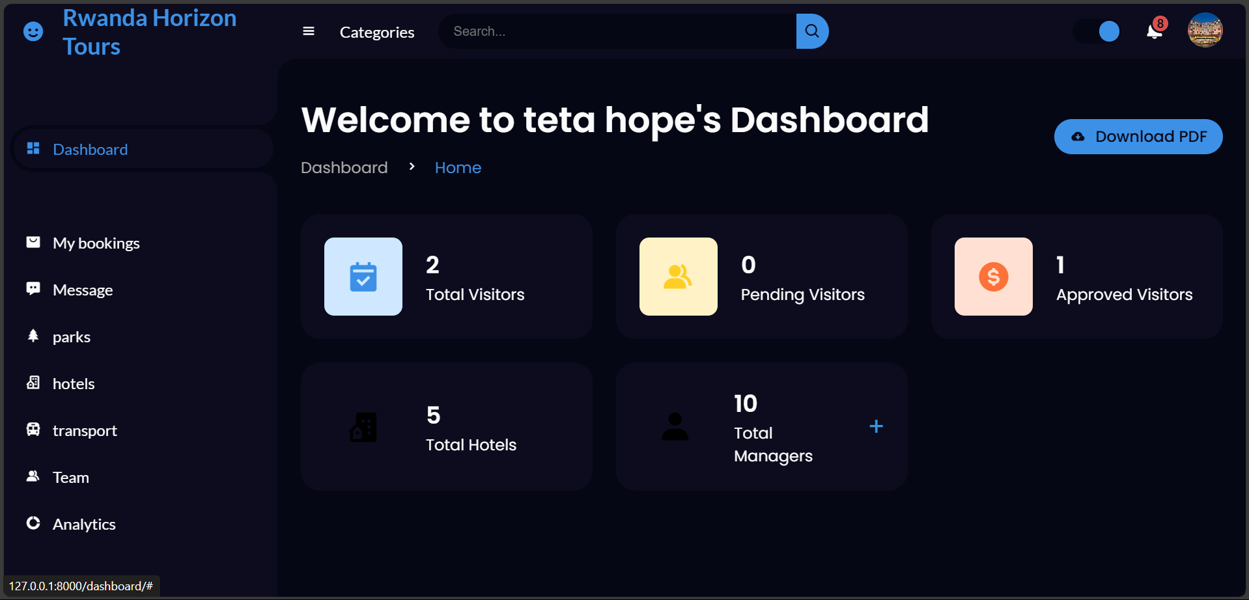

Figure 9: ADMIN DASHBOARD

**MY BOOKINGS IN DASHBOARD:**

As we saw above in dashboard page there is left side container that holds different action that take place in dashboard. The first one and what we are going to see here is my booking page this was page created to manager all booking transactions that took place from user/visitor by manager and as you can see below there are all information for the bookings and even there is feature that allow the manager to delete and approve the unproved one.

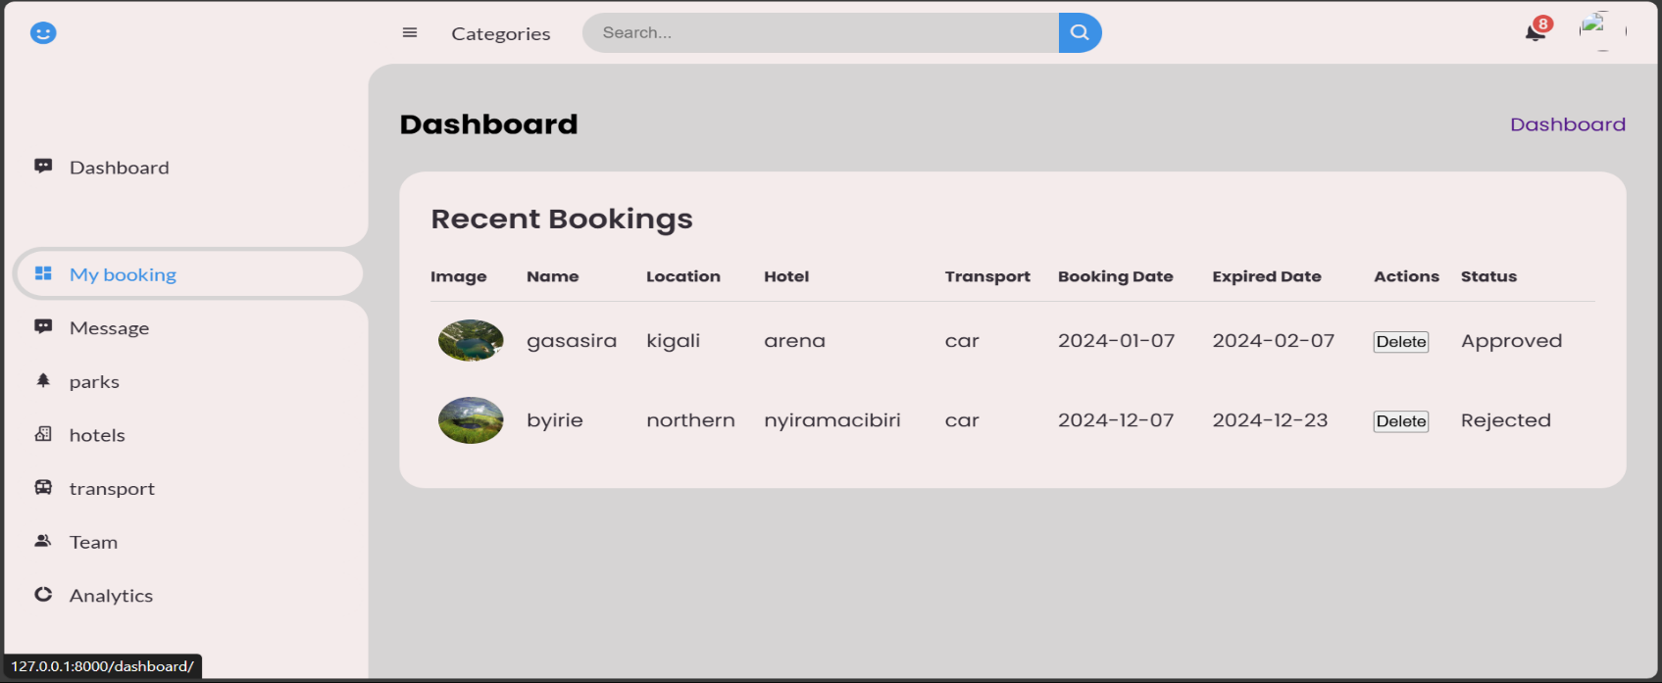

Figure Add admin page (Officer Cadet Management system) 2023-2024

Figure 11: DASHBOARD FOR SHOWING BOOKINGS

**MANAGER PAGE:**

This is page also designed in dashboard that display all managers that has account in our system and as you can see all information of the manager is here as he/she filled the registration form so, this page is here to help as know who are our managers and make modifications if it is necessary.

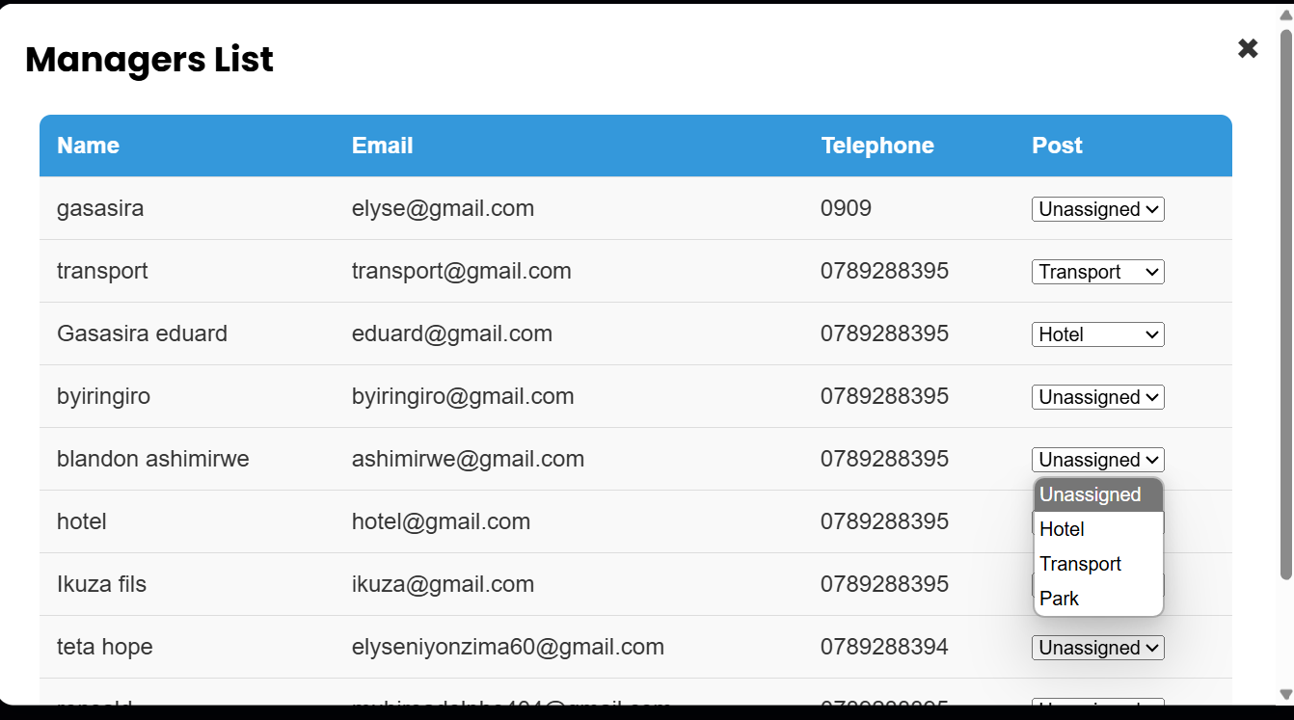

Figure 12: DASHBOARD SHOWING THE LIST OF MANAGERS ADDED TO THE DATABASE

**PARKS PAGE FROM DASHBOARD:**

the third left container feature is parks, so this was the page created to describe all information of our parks as place to visit and its actually includes fully news for our parks for both database and model.

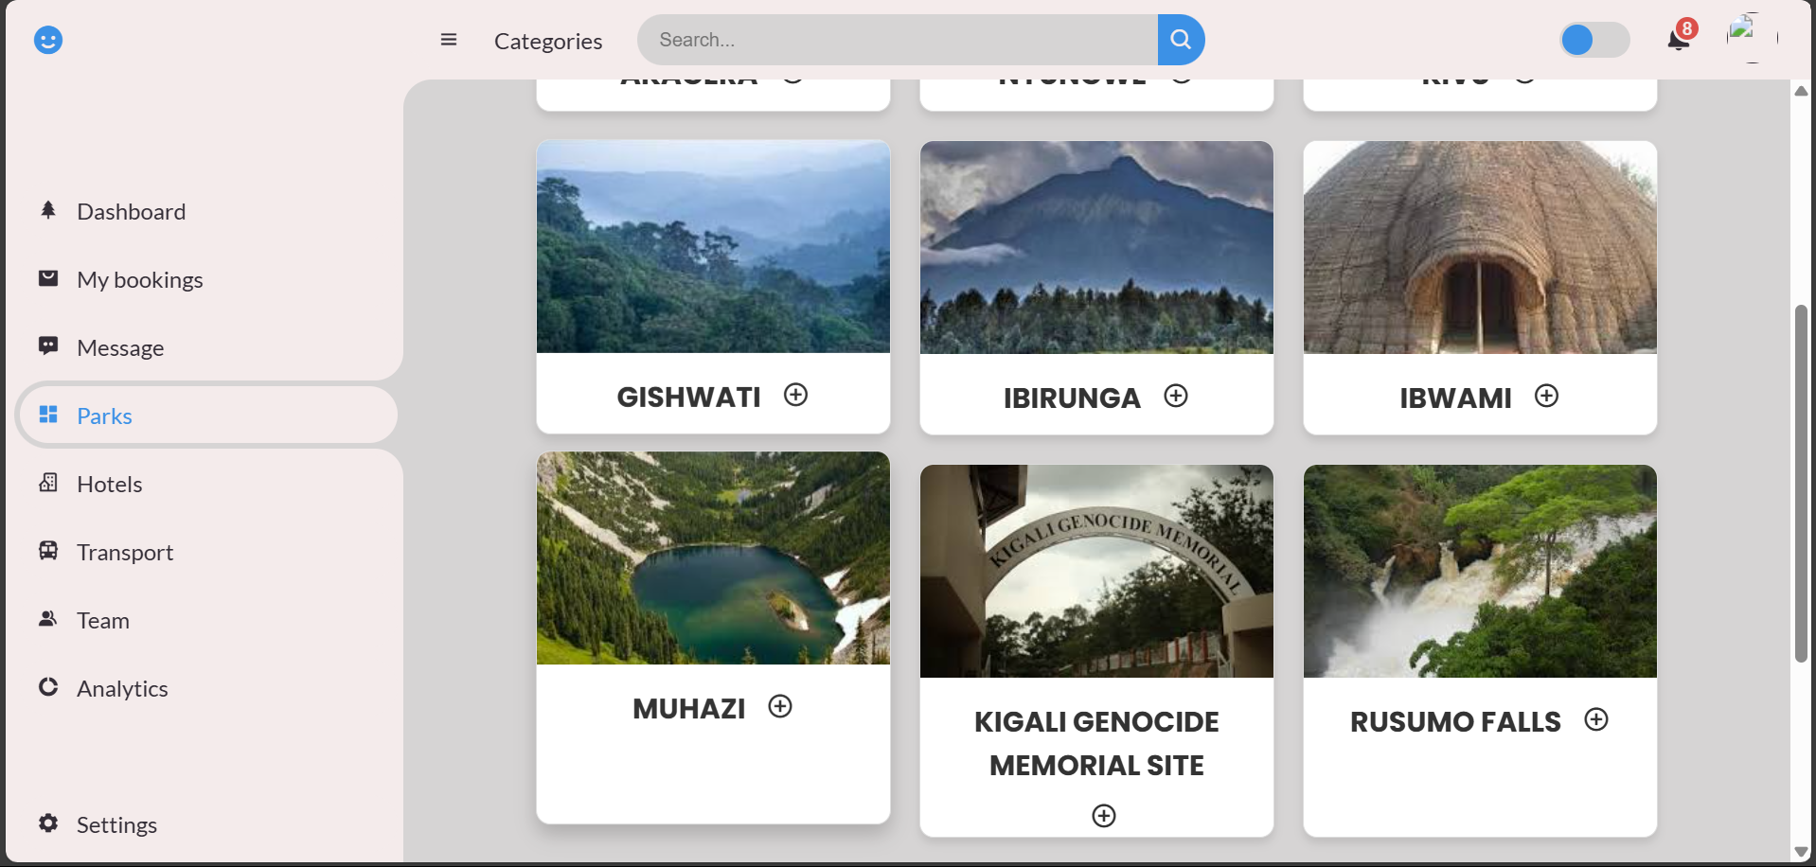

Figure 13:PARKS AND OTHER VISIT SITE

**DETAILS INVOICE:**

This is a pop up message that describe all features of destinations after being selected from others,

The difference in this message is that its describe the destinations approximately updates that are basically needed.

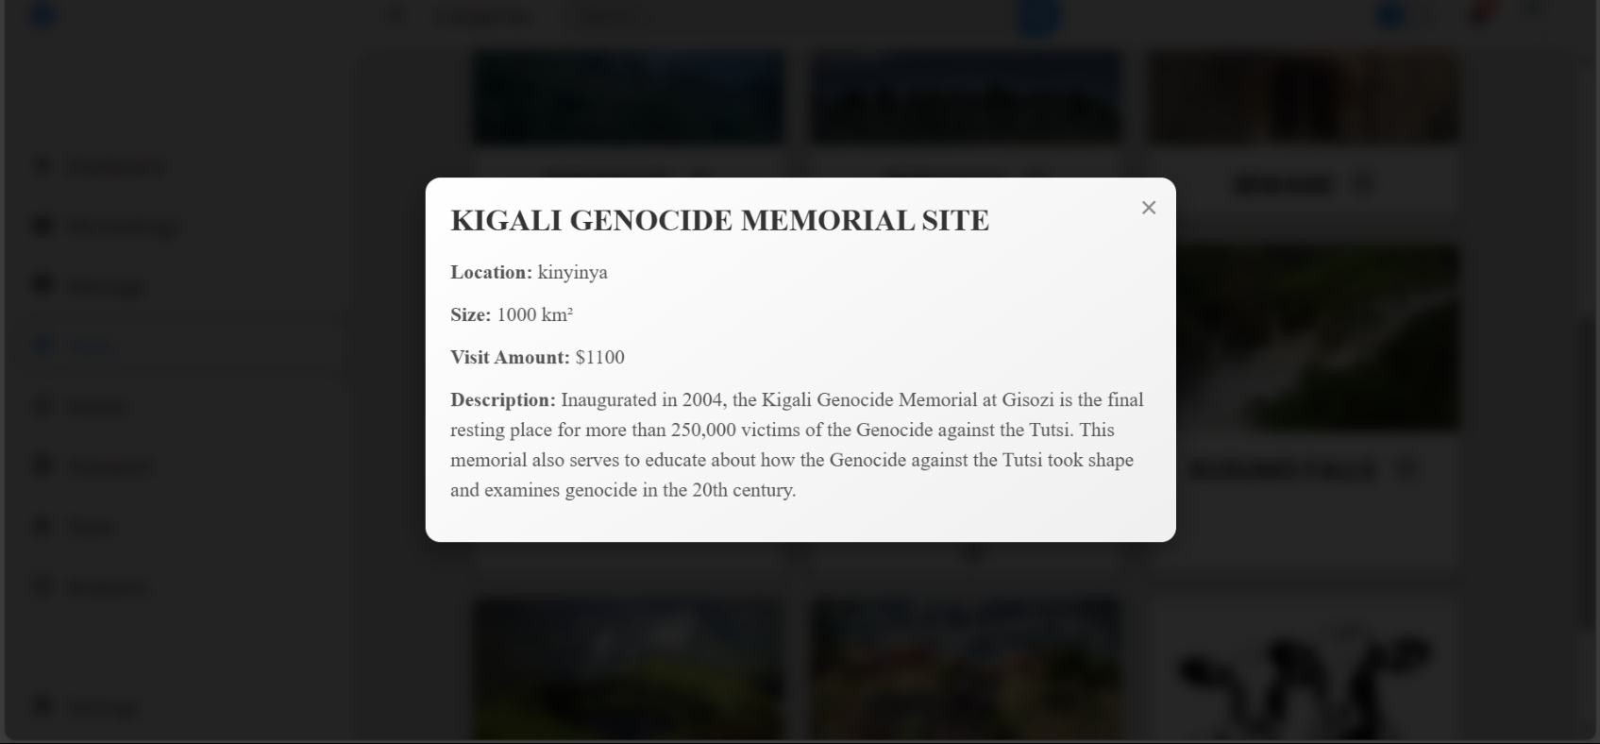

Figure 14: PAGE SHOWING THE DESCRIPTION OF EACH SITE

## Chapter 4. Conclusion

The "Rwanda Horizon Tours" project is set to revolutionize the tourism experience in Rwanda by addressing the huge challenges faced by tourists and local businesses alike. We have created a platform that improves the access to vital information for tourists while promoting local services through a user-friendly web application.  
  
Our project has successfully identified some key issues, such as the absence of comprehensive information on attractions and the inability of local businesses to reach out to their potential customers. By making it easy to book, communicate, and promote their services, we are creating a better tourism ecosystem in Rwanda.  
  
The implementation phase has shown a fair level of success, where about 90% of the functionalities were realized. Feedback collected from early users attests to the fact that the platform simplifies the process of travel planning and generally enriches the visitor experience.  
  
Moving forward, we continue to make improvements, especially on data management and user engagement features, and are committed to tuning these aspects to keep the platform responsive to user needs and industry trends.  
  
In summary, "Rwanda Horizon Tours" serves not only as a link between tourists and local service providers but also as a means of ensuring that tourism development in Rwanda becomes sustainable. We believe that this will be the dawn of satisfaction for visitors, which will promote economic growth and showcase Rwanda's rich cultural heritage. We look forward to future enhancements and collaboration to make this an indispensable tool for both the tourist and the local businesses involved.

I encourage the stakeholders and users to approach the platform with a collaborative mindset for continuous improvement. Feedback from users is invaluable, and I encourage them to share their insights and experiences in refining the system further. Your guidance and suggestions will be of immense help in enhancing the quality and effectiveness of this project.  
  
They should make full use of the functionalities available and seek help whenever in need so that they can have maximum utilization. I am committed to the provision of necessary support, which includes training sessions and virtual assistance in order to help users in navigating the system effectively. Attention to the system notifications and guidelines will also enhance user experience and outcomes.  
  
The first implementation of basic functionalities to our partners allows them to engage in it immediately and accrue benefits. Moving forward, I can assure all users that the system is efficient with minimal delays to ensure a smooth experience.

## Appendix:

#### LINK OF GITHUB:

#### <https://github.com/Munyembuga/Agroexchangetrading.git>

#### LINK OF FIGMA:

<https://munyembuga.github.io/Agroexchangetrading/>